The Plains Indians: Artists of Earth and Sky
March 9-May 10, 2015

12 available image files
- 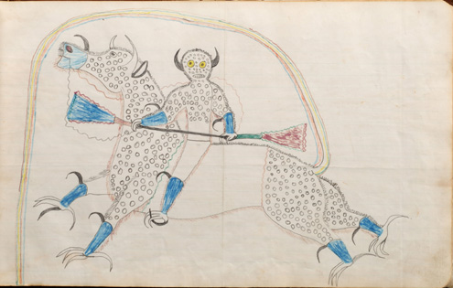
Drawing
Black Hawk (1832?-c. 1889?), Sans Arc Lakota (Teton Sioux), South Dakota
Dream or Vision or Himself Changed to a Destroyer or Riding a Bufalo Eagle, 1880 – 1881
Paper, ink, graphite
10 x 16 in. (25.4 x 40.6 cm)
Cooperstown (New York), Fenimore Art Museum, The Thaw Collection, gift of Eugene V. and Clare E. Thaw
Photo: New York State Historical Association, Fenimore Art Museum/John Bigelow Taylor
(Cat.85)
- 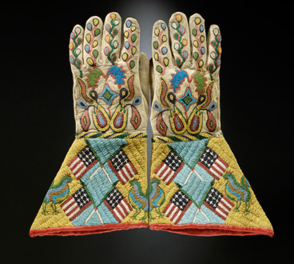
Gauntlets, c. 1890
Sioux-Métis artist, North or South Dakota
Native tanned leather, glass and brass beads, cotton cloth
14 ½ x 8 in. (36.8 x 20.3 cm)
United States, Hirschfield Family Collection, Courtesy of Berte and Alan Hirschfield
Photo: Hirschfield Family Collection, courtesy of Berte and Alan Hirschfield/ W. Garth Dowling
(Cat.94)
- 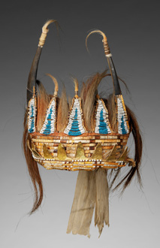
Horned Headdress, c. 1780
Eastern Plains artists, Lower Missouri River Region
Split bison horns, sinew, horsehair, deer hair, porcupine quills, glass beads, wood, metal cones, cotton cloth, rawhide, birch bark (?), silk ribbon, pigment
12 x 10 7/8 in x 16 ½ in. (30.5 x 27.6 x 41.9 cm)
Paris (France), musée du quai Branly
Photo: Musée du quai Branly/Patrick Gries, Bruno Descoings
(Cat.16)
- 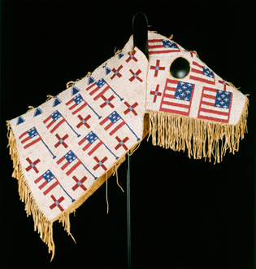
Horse Mask, c. 1900
Lakota (Teton Sioux) artist, North or South Dakota
Native tanned leather, glass beads
28 ½ x 35 in. (72.4 x 88.9 cm)
Cooperstown (New York), Fenimore Art Museum, The Thaw Collection, gift of Eugene V. and Clare E. Thaw
Photo: New York State Historical Association, Fenimore Art Museum,The Thaw Collection
(Cat.107)
- 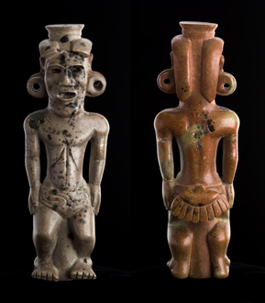
Human Effigy Pipe, 100 B.C. – A.D. 100
Adena or Hopewell artist, Adena Mound, Ross County (Ohio) Pipestone
7 7/8 in. (20 cm)
Columbus (Ohio), Ohio Historical Society
Photo: Ohio Historical Society
(Cat.1)
- 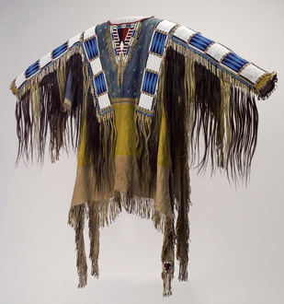
Man’s Shirt, 1865
Oglala Lakota (Teton Sioux) artists, South Dakota
Native tanned leather, pigment, human hair, horsehair, glass beads, porcupine quills
58 x 42 ½ in. (147.3 x 108 cm)
Cody (Wyoming), Buffalo Bill Center of the West, Collection Adolf Spohr, gift of Larry Sheerin
Photo: Buffalo Bill Center of the West
(Cat.72)

- 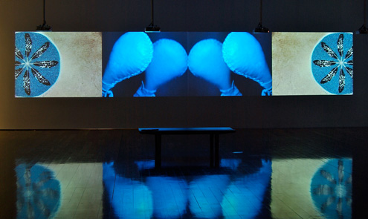
Rattle, 2003
Dana Claxton (1959-), Hunkpapa Lakota (Sioux), Saskatchewan, Canada
4-channel video
Size variable to some extent based on projection
Dana Claxton and Winsor Gallery
Photo: Courtesy of The Metropolitan Museum of Art
- 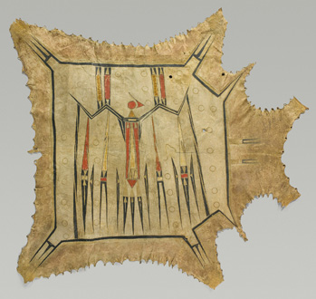
Robe, c.1700 – 1740 – [The MET gave me a reproduction of a different robe from Peabody Museum Collection at Harvard, but I will request this one from them as well]
Eastern Plains artist, probably Illinois, Mid-Mississippi River basin
Native tanned leather, pigment
42 3/8 x 47 7/8 in. (107.7 x 121.4 cm)
Paris (France), musée du quai Branly
Photo: Musée du quai Branly/Thierry Ollivier, Michel Urtado
(Cat.9)
- 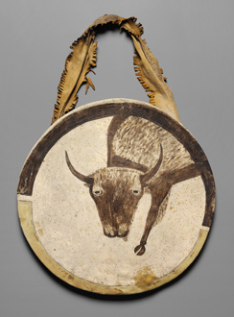
Shield, c. 1850
Arikara artist, North Dakota
Buffalo rawhide, native tanned leather, pigment
Diameter: 20 in. (50.8 cm)
Kansas City (Missouri), The Nelson-Atkins Museum of Art, Purchase: the Donald D. Jones Fund for
American Indian Art
Photo: The Nelson-Atkins Museum of Art/Jamison Miller
(Cat.55)
- 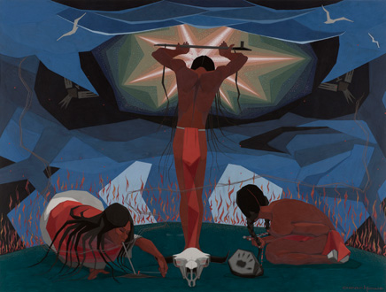
Calling on Wakan Tanka, 1962
Oscar Howe, Mazuha Hokshina, Trader Boy (1915-1983), Yanktonai, South Dakota
Paper, casein
22 3/8 x 31 ¼ in. (56.8 x 79.4 cm)
Vermillion (South Dakota), The University of South Dakota, donation from the artist
Photo: The University of South Dakota/John Lamberton
(Cat.124)
- 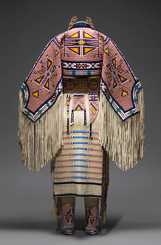
Woman’s Dress and Accessories, 2005
Jodi Gillette (1959-), Hunkpapa Lakota (Teton Sioux), North Dakota
Native tanned and commercial leather, glass and metal beads, cotton cloth, silk, dentalium shell, metal cones, horsehair, plastic, hair pipes, brass bells, porcupine quills, brass tacks, brass and metal studs, silver cones
54 × 60 in. (137.2 × 152.4 cm)
United States, Courtesy of Jodi Gillette
Photo: Joshua Ferdinand, courtesy of Jodi Gillette
(Cat.134)
- 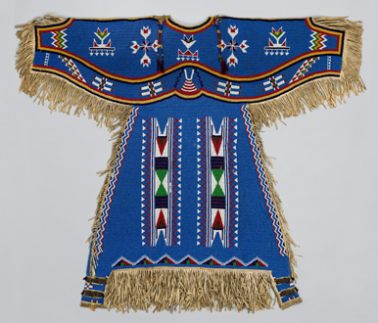
Woman’s Dress, c. 1900
Dakota (Eastern Sioux), Yanktonai or Lakota (Teton Sioux) artist, Fort Peck Reservation (Montana) Native tanned leather, glass, brass and steel-cut beads, metal cones, horsehair
48 x 39 in. (121.9 x 99.1 cm)
Washington (District of Columbia), Smithsonian Institution, National Museum of Natural History, Department of Anthropology
Photo: National Museum of Natural History, Smithsonian Institution, Department of Anthropology
(Cat.109)
Caption for the robe from Musée du quai Branly:
Robe, c. 1800-1830
Central Plains Artists
Native tanned leather, pigment, porcupine quills,
58 3/8 x 88 ¼ in. (148.3 x 224.2 cm)
Paris (France), musée du quai Branly, gift of Chaplain-Duparc 71.1886.17.1
Photo: Musée du quai Branly/Patrick Gries, Valérie Torre

Caption for Wounded Knee III by Arthur Amiotte:

Wounded Knee #III, 2001
Arthur Amiotte (1942-), Oglala Lakota (Teton Sioux), South Dakota
Canvas, paper, ink
36 × 48 in. (91.4 × 121.9 cm)
Chicago (Illinois), The University of Chicago, lent by the David and Alfred Smart Museum of Art, gift of
Robert and Miranda Donnelley
Photo: The David and Alfred Smart Museum of Art, The University of Chicago

