Hayal Pozanti, STUDIO INTERNATIONAL Checklist

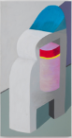
Neopoints, 2014
Acrylic on canvas
74 x 40 inches

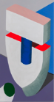
Masters of Suspicion, 2014
Acrylic on canvas
74 x 40 inches

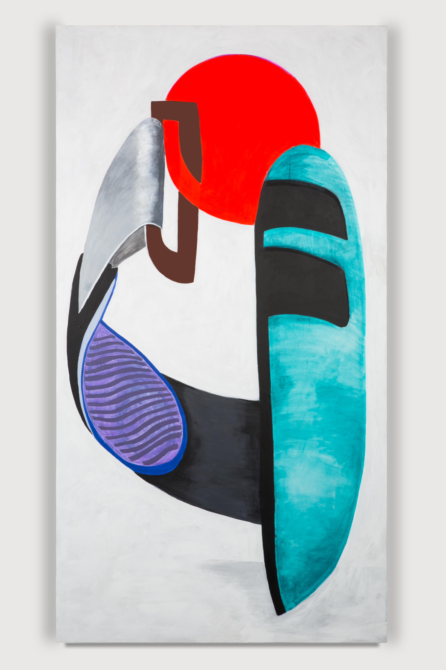
The Family Drone, 2014
Acrylic on canvas
74 x 40 inches

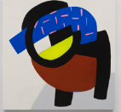
Archival Alchemy, 2014
Acrylic on wood panel
45 x 45 inches

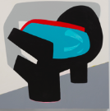
Reflex Impulse, 2014
Acrylic on wood panel
45 x 45 inches

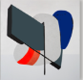
Data Double, 2014
Acrylic on wood panel
40 x 40 inches

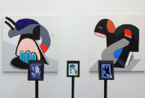
Hayal Pozanti, Install view from The Armory, 2014

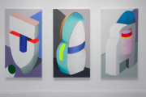
Hayal Pozanti, Install view from FIAC Paris, 2014

